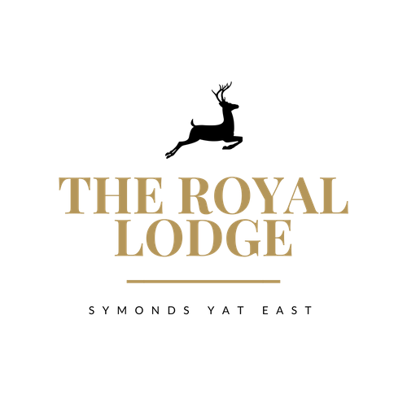

THE LODGE MENU

STARTERS
Chicken Liver Pate, Onion Jam, Brown Toast (W, Sul, M) | £9.95
Classic Prawn Cocktail, Lettuce and Brown Bread (Cr, W, M,) | £9.95
Homemade Soup of the Day, Served with Warm Baguette  (Please ask your server for today’s Taste) (C, V, W, M) | £8.95
Buffalo Chicken Wings with BBQ Sauce (M, W) | £9.95
Crispy Teriyaki Tofu, Served with Warm Greens and Chilli (So, S, W) (Vegan) | £9.95
Pan Fried Garlic and Thyme Mushrooms, Cream Sauce, Soft Poached Egg and Parmesan Shavings on Toasted Focaccia (M, W, E) | £11.95
Roasted Florets of Cauliflower Satay (So) (Vegan) | £9.95

SIDE ORDERS
Chips (W) | £4.95
Chips with Cheese (W, M) | £5.95
Garlic Bread (V, W, M) | £4.95
Garlic Bread with Cheese (V, W,M) | £5.95
Mixed Seasonal Veg (V) £4.95
CHILDREN’S MENU

All children’s menu items are served with a choice of Chips (W), Mash or New Potatoes. Except Dishes Marked #
Battered Chicken Nuggets, Peas or Beans (W) | £10.95
Pork Sausages, Peas or Beans | £10.95
Breaded Scampi, Peas or Beans (W, Cr) | £10.95
Welsh Black Beef Burger Brioche Bun, Cheese, Bacon (W, M, E) | £10.95
# Mushroom, Courgette & Sweet Potato Risotto (Vegan) | £10.95
# Spaghetti Bolognese, served with Parmesan and Garlic Bread (C, Sul, M, W) | £10.95

ALLERGENS
C=Celery, L=Lupin, N=Nut, Sul=Sulphur Dioxide, Cr=Crustacean, M=Milk, So=Soya P=Peanut, W=Wheat, E=Egg, Mol=Mollusc, S=Sesame, V=Vegetarian, F=Fish, Mu=Mustard

An optional 10% service charge will be added to your bill

MAIN COURSES

Mains served with a choice of Chips (W), New Potatoes (M) or Dauphinoise Potatoes (M), Except dishes marked #
Beef, Ale & Mushroom Pie Mixed Vegetables, Gravy (Sul, W) | £19.95
10oz 28 Day Aged Sirloin Steak Creamy Garlic & Chive Mushrooms, Grilled Tomato (M)  (Add Pepper Sauce - £2.95) (Sul, M) | £30.95
Home Cooked Honey and Mustard Roasted Ham, Fried Eggs and Peas (E, Mu) | £16.95
# West Indian Prawn (Cr, W) or Chicken Pathia Curry (W)  Prawn or Chicken Medium Spiced Curry with Rice, Poppadom, Chutney & Naan Bread | £27.95
# Spaghetti Bolognaise, served with Parmesan Shavings and Garlic Bread (C, Sul, M, W, E) | £18.95
# Beetroot and Butternut Squash Wellington, Salad and Pepper Couscous (W, So, V, Vegan) | £19.95
# Mushroom, Courgette & Sweet Potato and Cheese Risotto (C, Sul, Vegan) | £18.95
# Moroccan Mixed Vegetable Tagine (Vegan) and Flatbread (W) | £18.95
Pan Seared Fillet of Sea Bass, Charred Pak Choi, Lemon Caper Butter (F, M) | £24.95
# Pressed Local Pork Belly, Roasted Baby Carrots, Tenderstem Broccoli,  Fondant Potato and Cider Sauce (M, Sul, C)  # Trio of Award-Winning Sausages, Buttered Mashed Potatoes, Caramelised  Onion Gravy and Garden Peas (M, W) | £25.95  £15.95
# Lamb Rump, Petit Ratatouille, Buttered Mashed  Potatoes with a Red Wine Reduction (Sul, M) | £27.95
Wye Valley Battered Haddock Peas, Tartare Sauce and Mixed Salad (W, M, F) | £19.95

LODGE DESSERT MENU

Chocolate Fondant with Vanilla Ice Cream (GF, E, M, V) | £9.95
Chocolate Brownie Ice Cream Sundae (M, V, GF) | £9.95
Trio of Ice Cream (GF, V) OR Trio of Sorbet (V, Vegan) | £7.50
Vanilla Panacotta with Strawberry Compote and Vanilla Shortbread (M, W, E, V) | £9.95
Apple & Mixed Berry Crumble with Cream, Custard or Ice Cream (M, V, GF) | £9.95
Lemon and Chocolate Cheesecake (W, M, V) | £9.95
Lodge Baked Apple Pie with Choice of Cream, Custard or Ice Cream (W, M, V) | £9.95
Royal Lodge Cheese Slate Selection of three Cheeses with Pepper and Sea Salt Butter, Quince, Fruit Chutney, Grapes, Celery and Mixed Biscuits (M, C, W, Mu, S, V) | £12.95

ALLERGENS
C=Celery, L=Lupin, N=Nut, Sul=Sulphur Dioxide, Cr=Crustacean, M=Milk, So=Soya P=Peanut, W=Wheat, E=Egg, Mol=Mollusc, S=Sesame, V=Vegetarian, F=Fish, Mu=Mustard
An optional 10% service charge will be added to your bill

